File & Voice Security Documentation
Enhancing Security in Messaging Applications
Spinnaker Analytics
27 June 2026

Table of Contents
- Introduction
- File Security Architecture
- Secure File Encryption
- Secure File Storage
- File Transfer Security Controls
- Voice Communication Security
- Secure Voice Call Architecture
- Voice Call Protection Controls
- Security Validation & Testing
- Security Considerations
- Conclusion

1. Introduction

1.1 Purpose
- This document defines the security controls implemented to protect file transfers and voice communications within the messaging application.
- The objective is to ensure confidentiality, integrity, authenticity, and secure storage of user-generated content while protecting voice communications against interception, tampering, and unauthorized access.

1.2 Objectives
- Protect files before transmission
- Secure file storage on client and server systems
- Ensure encrypted file transfers
- Secure real-time voice communications
- Prevent unauthorized access to stored content
- Maintain message and call confidentiality
- Validate security controls through testing

2. File Security Architecture
Files are protected using a layered security model.
Figure 15 – File Security Architecture
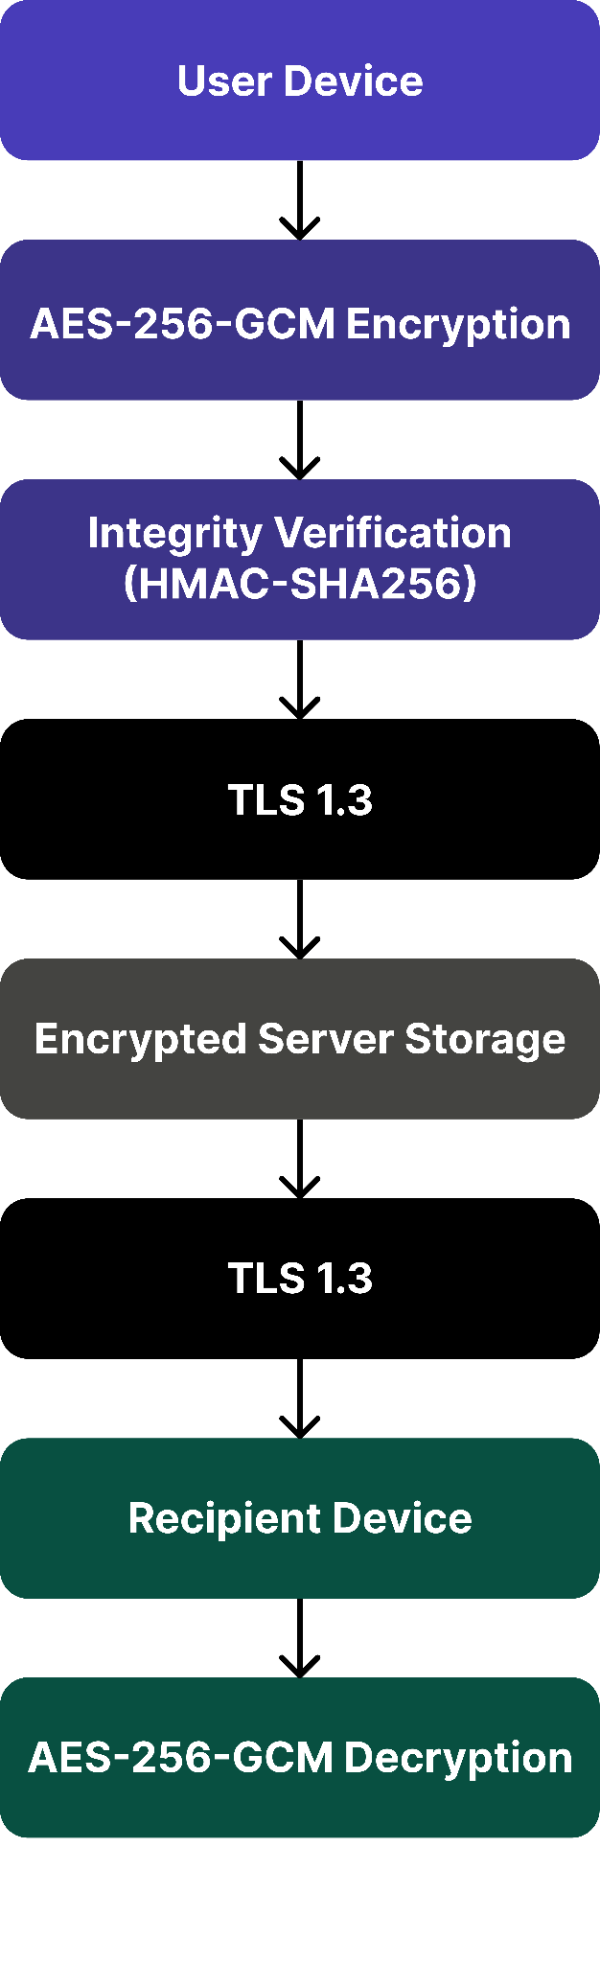

2.1 Security Layers

Layer | Protection
Application Layer | AES-256-GCM
Integrity Layer | HMAC-SHA256
Transport Layer | TLS 1.3
Storage Layer | SQLCipher
Device Layer | Full Disk Encryption

3. Secure File Encryption

3.1 Encryption Process
- Before transmission:
  - File selected
  - Unique encryption key generated
  - AES-256-GCM encryption applied
  - Integrity tag generated
  - Ciphertext transmitted

3.2 File Encryption
Figure 16 – File Encryption Workflow
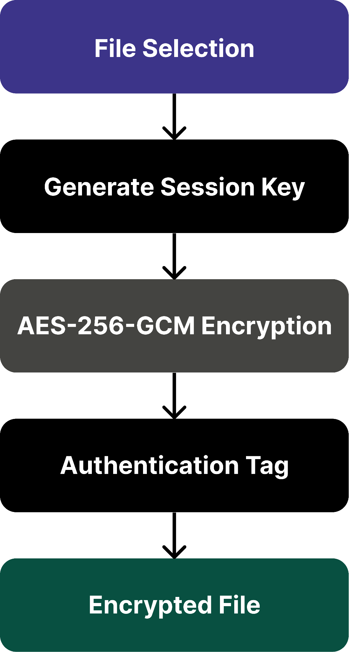

3.3 Encryption Parameters

Parameter | Value
Algorithm | AES-256-GCM
Key Length | 256-bit
Nonce Length | 96-bit
Authentication Tag | 128-bit
Key Generation | CSPRNG

3.4 Security Benefits
- Confidentiality
- Integrity
- Tamper detection
- Replay protection

4. Secure File Storage

4.1 Client-Side Storage
- Encrypted files stored locally using:

Android
    - Android Keystore
    - Full Disk Encryption
    - SQLCipher

iOS
    - Secure Enclave
    - Data Protection API
    - Keychain Services

4.2 Secure Storage
Figure 17 – Secure Storage Architecture
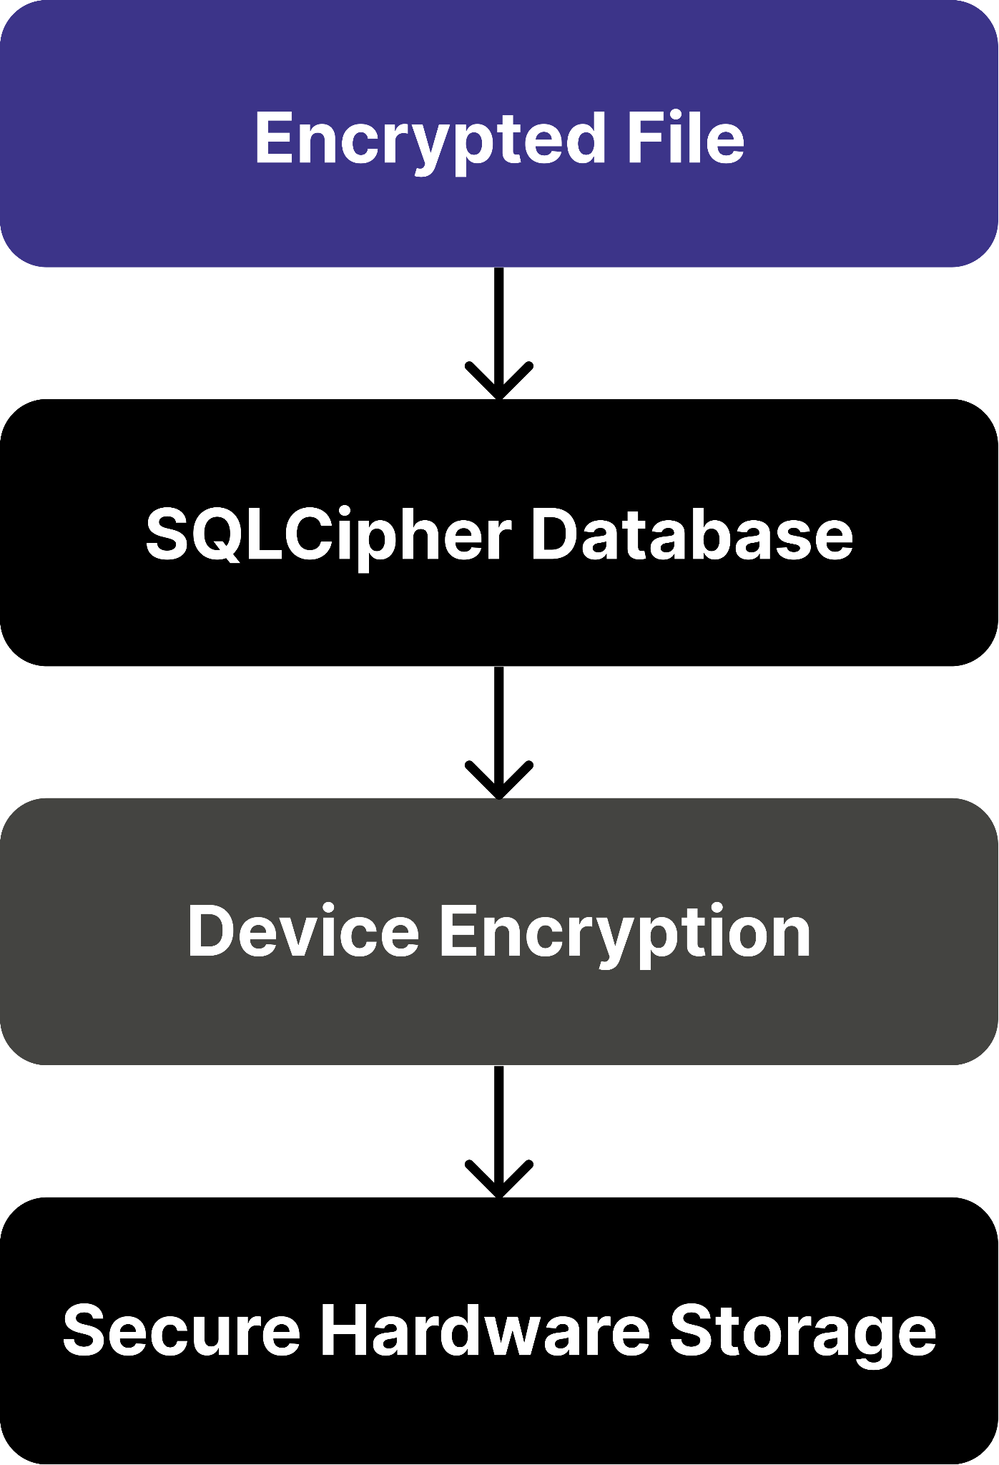

4.3 Server-Side Storage
- Server storage remains encrypted.
  - Controls
    - AES-256 encrypted storage
    - Encrypted backups
    - Metadata separation
    - Access logging

Storage Location | Protection
Android Device | Keystore + FDE
iOS Device | Secure Enclave
SQLCipher Database | AES-256
Server Storage | AES-256
Backups | Encrypted

4.4 Data Classification
Data Type | Protection
Files | AES-256
Metadata | Restricted Access
Logs | Retention Policy
Backups | Encrypted

5. File Transfer Security Controls

5.1 Transport Security
- All transfers occur through:
  - TLS 1.3

5.2 Cipher Suites
- Cipher Suite
  - TLS_AES_256_GCM_SHA384
  - TLS_CHACHA20_POLY1305_SHA256

5.3 Security Controls

Certificate Validation
  - Trusted CA verification
  - Certificate chain validation

Perfect Forward Secrecy
  - Implemented using:
    - ECDHE
Figure 18 – Secure File Transfer Process
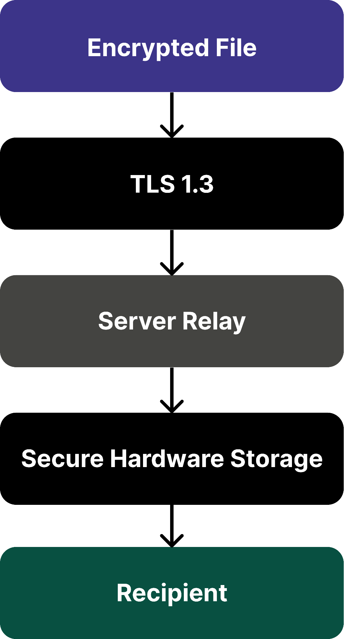

6. Voice Communication Security
- Voice communication security is implemented using secure real-time communication protocols.

6.1 Security Objectives
- Confidentiality
- Integrity
- Authentication
- Forward Secrecy
- Real-Time Performance

6.2 Voice Security Components

Component | Technology
Signaling | TLS 1.3
Key Exchange | DTLS
Voice Encryption | SRTP
Key Agreement | ECDHE
Integrity Protection | SRTP Authentication

7. Secure Voice Call Architecture
Figure 19 – Secure Voice Call Architecture
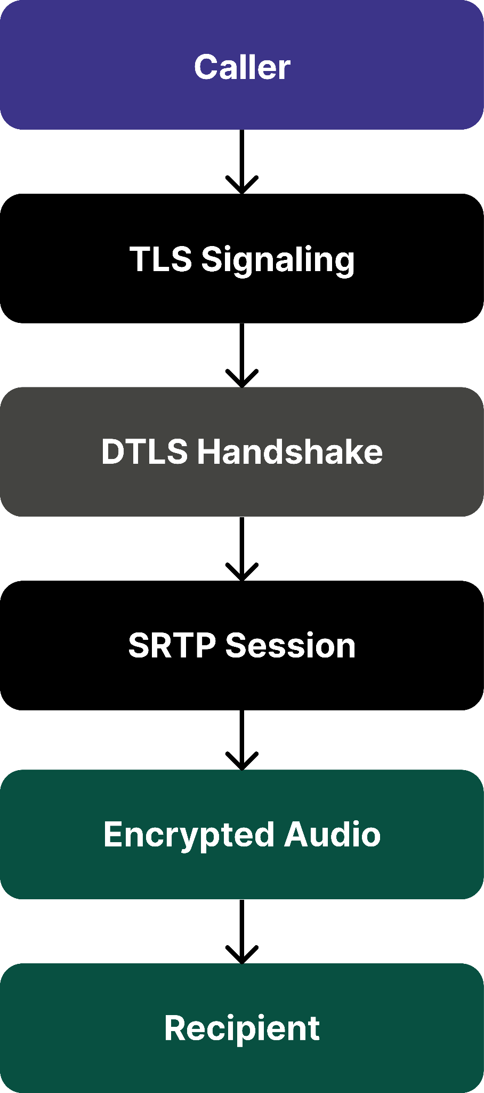

7.1 Call Establishment Process
- Step 1
  - Call Initiation
- Step 2
  - TLS Signaling
- Step 3
  - DTLS Handshake
- Step 4
  - ECDHE Key Exchange
- Step 5
  - SRTP Session Creation
- Step 6
  - Encrypted Audio Streaming

8. Voice Call Protection Controls

8.1 Encryption Parameters

Parameter | Value
Protocol | SRTP
Cipher | AES-128-GCM
Key Exchange | DTLS
Forward Secrecy | ECDHE
Authentication | SRTP Integrity Checks

8.2 Security Controls
- Protection Against Eavesdropping
  - SRTP Encryption
  - TLS Signaling
- Protection Against Replay Attacks
  - Sequence Numbers
  - Session Validation
- Protection Against Session Hijacking
  - DTLS Authentication
  - Ephemeral Session Keys

Figure 20 – Voice Security Layers
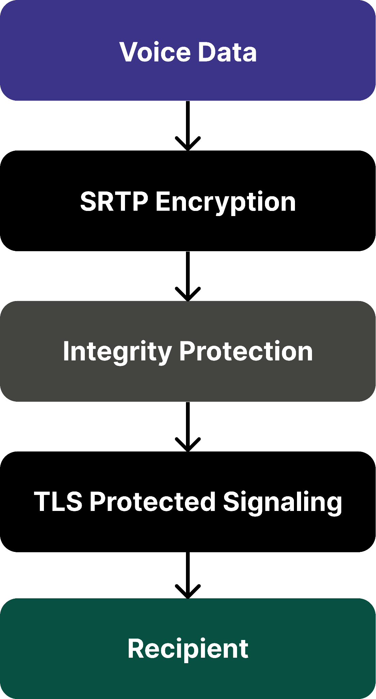

9. Security Validation & Testing

9.1 Testing Environment
Tool | Purpose
Wireshark | Traffic Analysis
Burp Suite | TLS Verification
MobSF | Mobile Security Assessment
OpenSSL | Certificate Validation

9.2 Validation Objectives
- File Security
  - Verify:
    - File encrypted before upload
    - Encrypted storage active
    - No plaintext transfer
- Voice Security
  - Verify:
    - SRTP traffic present
    - No plaintext audio
    - TLS signaling active

9.3 Test Cases
Test ID | Test Scenario | Expected Result
FILE-01 | Upload file | Encrypted file
FILE-02 | Download file | Successful decryption
FILE-03 | Inspect traffic | Ciphertext only
VOICE-01 | Voice call | SRTP traffic
VOICE-02 | TLS inspection | TLS 1.3 verified
VOICE-03 | Replay simulation | Rejected

9.4 Expected Evidence
- Wireshark packet captures
- TLS handshake screenshots
- MobSF assessment reports
- Encrypted storage screenshots

10. Security Considerations

10.1 Threats & Mitigations

Threat | Mitigation
File Interception | AES-256-GCM
Data Tampering | HMAC-SHA256
MITM Attacks | TLS 1.3
Replay Attacks | Nonces
Voice Eavesdropping | SRTP
Session Hijacking | DTLS

10.2 Standards Alignment
Standard | Purpose
RFC 3711 | SRTP
RFC 8446 | TLS 1.3
NIST SP 800-57 | Key Management
OWASP MASVS | Mobile Security
OWASP MSTG | Mobile Testing

11. Conclusion
- This File & Voice Security Documentation defines the controls used to secure file transfers and voice communications throughout their lifecycle.
  - The solution combines:
    - AES-256-GCM file encryption
    - SQLCipher secure storage
    - TLS 1.3 transport protection
    - DTLS key exchange
    - SRTP voice encryption
    - Perfect Forward Secrecy
    - Comprehensive validation testing
- These controls ensure confidentiality, integrity, and availability of user communications while protecting against modern cyber threats such as interception, tampering, replay attacks, and unauthorized access.

